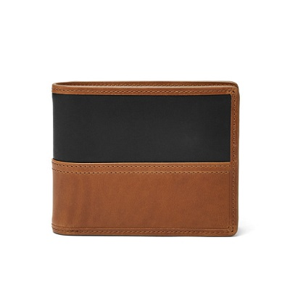

TATE RFID LARGE COIN POCKET BIFOLD

PRODUCT DETAILS

**Silhouette: Large Coin Pocket Bifold**

**Exterior Material: Leather**

**Interior Details: 8 Credit Card Slots, 1 Billfold Pocket, 2 Slide Pockets, 1 ID Window**

**Measurements: 4.60"L x 0.78"W x 3.74"H**

**Warranty: 1 Year Limited**